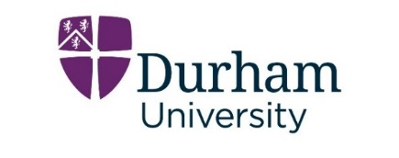
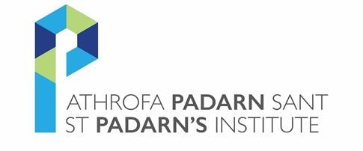

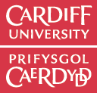
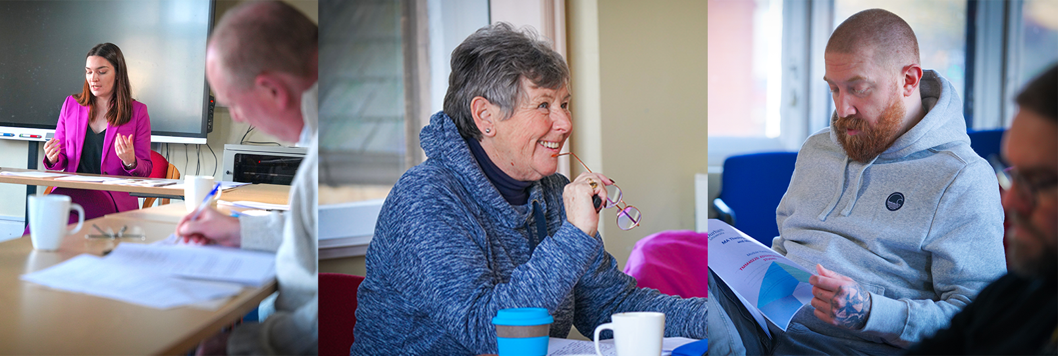
MA in Theology, Ministry and Mission

www.stpadarns.ac.uk/MATheology

Validated by Durham University Common Awards

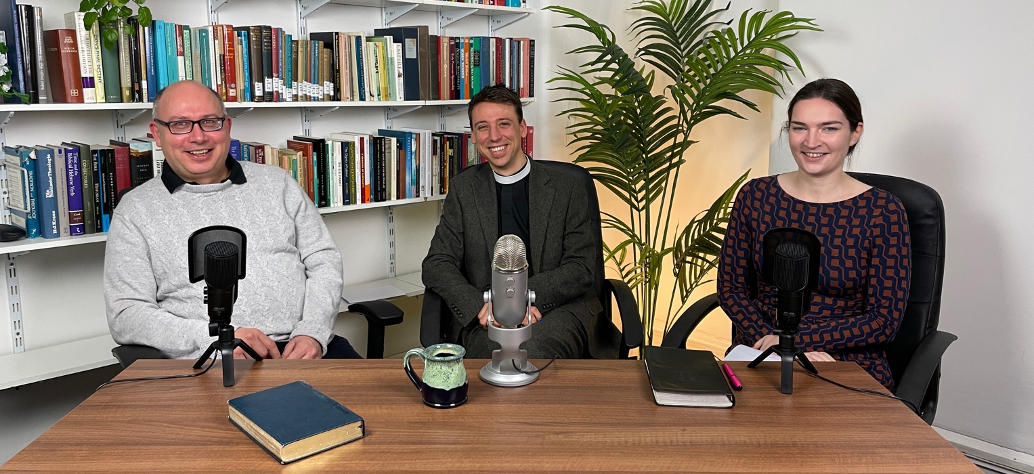

ABOUT ST PADARN’S INSTITUTE
St Padarn’s is the training arm of the Church in Wales. It seeks to play its part in equipping and empowering God’s people across the world to communicate God’s transformative love.

WHY STUDY ST PADARN’S MA IN THEOLOGY, MINISTRY, AND MISSION?
Our MA in Theology, Ministry, and Mission is validated by Durham University which is part of the prestigious Russell Group and one of the top universities for theology in the world. St Padarn’s vision for theological education combines academic excellence with commitment to formation and mission, and the MA course is very much a reflection of that vision. It will give you a good grounding in Biblical studies, Christian doctrine, missiology, practical theology, and will allow you to explore topics that are of particular importance to you. Within your chosen subjects, there will be much freedom to concentrate on your own specific areas of interest or root your study in your own situation or locality.

This is a flexible, part-time course, designed to serve people who juggle a variety of demands and commitments. It is delivered in a way that gives freedom to those who are busy with ministry, who have other jobs, or who live further away.

The MA draws on internationally-recognised expertise. Your tutors are experts in various theological and biblical fields and their academic work is renowned to be sensitive to current issues in ministry and in the public eye.

WHO IS THE COURSE FOR?
The MA is aimed primarily at those in lay or ordained Christian ministry and is open to all demoninations and theological traditions. It is also suitable for people who work for para-church organisations, whose mission field is the ‘secular’ workplace, or who seek to serve their local church in an informal capacity. Theology or religious studies graduates who want to further their learning will find it equally valuable.

Do you want to deepen your knowledge of the Bible? Do you want to expand the horizons of your theological understanding? Do you want to hone your skills for ministry, mission, and leadership? Do you want to explore how your faith relates to the realities of today’s world? If yes, St Padarn’s MA is the course for you.

WHAT ARE THE ENTRY REQUIREMENTS?
Applicants will normally have a degree in Theology or Religious Studies. However, there are alternative entry routes that allow people without formal theological education but with significant experience of ministry to apply. If that is you, please contact us for more information.
THE TEACHING TEAM

Elizabeth Corsar (PhD, University of Edinburgh) is Director of the BTh course and Tutor in Biblical Studies at St Padarn’s. Her research interests are in the Gospel of John and the relationships between canonical and non-canonical texts.

Jill Duff (DPhil, Oxford University) is Bishop of Lancaster and former Principal of St Mellitus North West. She has wide experience in mission, evangelism, social transformation, church planting and growth and has taught extensively on those subjects in academic and non-academic settings.

Alun Evans (PhD, Cardiff University) is Tutor in Mission at St Padarn’s. He is ordained in the Church in Wales and served in a range of parishes in St David’s Diocese. His research interests include the relationship between the Christian faith and culture, as well as contemporary church growth.
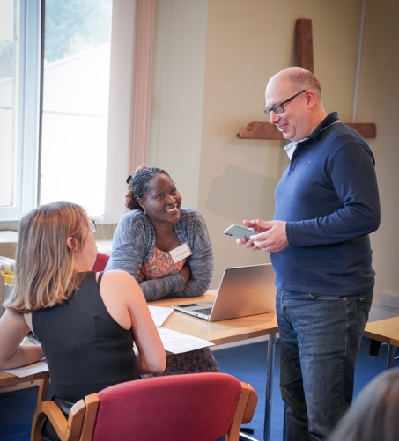
Charlie Hadjiev (DPhil, Oxford University) is Programme Director of the MA course and Tutor in Biblical Studies at St Padarn’s. He has extensive experience in theological education and Christian mission in UK and across Europe. His research interests include hermeneutics and Old Testament prophecy.

Jordan Hillebert (PhD, University of St Andrews) is Director of Formation and Tutor in Theology at St Padarn’s. He is ordained in the Church in Wales. His research interests are in systematic theology and modern Christian thought.

Jane Williams (PhD, Cambridge University) is a founding member of St Mellitus College and the McDonald Professor in Christian Theology. She has taught at King’s College London and Trinity College Bristol. She has written numerous books and has travelled extensively all over the world to teach, preach, and promote theological education.

HOW IS THE COURSE TAUGHT?
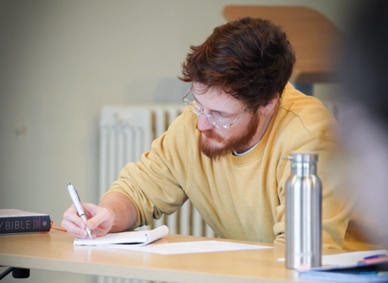
This is a part-time course (two years plus dissertation), designed to enable people with busy lives to study. It is delivered in a flexible way through three residentials per year supplemented by online provision and support.

The residentials take place from Monday to Wednesday at our site in Cardiff, where we enjoy an extensive library and well-equipped teaching rooms. You are welcome to worship alongside members of our theological college in our attractive chapel. Our en-suite accommodation is modern and purpose-built.

WHAT MODULES ARE OFFERED?
To complete the Masters programme you will need six taught modules and a 15,000 word dissertation on a topic of your choice. Current modules include:

The Bible and Christian Faith: Biblical Hermeneutics
This module explores what it means to read the Bible well. Are there legitimate and illegitimate ways of interpreting Scripture? Who decides and based on what criteria? How is our reading of the Bible linked to reason, faith, emotion, tradition, and community?

Advanced Biblical Studies: The Gospel of John
We will look at John's unique Christology and the way the gospel treats topics such as mission, discipleship, ethics, and "the Jews". We will also take into account how the gospel was interpreted by later generations of readers. Students will gain a vision of how biblical exegesis informs Christian life and ministry.

Christian Faith and the Environment
How can the teachings and practices of the Christian faith inform our understanding of creation and our relationships with other creatures? Is there a distinctly Christian interpretation of, and response to, the present environmental crises?

Reflective Practice: Mission and Evangelism
We will examine various biblical, historical, and theological perspectives on mission and will consider how they can be applied to specific local situations. Students will have opportunity to reflect on contemporary methods and strategies in mission and evangelism.

Advanced Topic in Christian Doctrine: The Trinity
The God whom Christians worship is Father, Son and Holy Spirit, One God in Three Persons. This is the basis from which everything else we understand about God flows. This module will help us to explore why only this God is able to be our Creator and Saviour.

Research and Reflection
Theological reflection is an important skill for effective Christian ministry. This module explores the nature and practice of this skill. We will look at different types and methods of research and consider how good research supports faithful Christian practice and ministry.

WHAT IS THE APPLICATION PROCESS?
Applications to be received by the 31 July for September start.
FOR MORE INFORMATION
Contact Tina Franklin, Postgraduate Coordinator:
tina.franklin@stpadarns.ac.uk
or visit
www.stpadarns.ac.uk/MATheology
St Padarn's Institute is part of the Representative Body of the Church in Wales
Registered Charity Number 1142813

