

Archdeacon of the Gwent Valleys and
Diocesan Director of Mission
The postholder will be accountable to the Diocesan Bishop and work collaboratively with the Diocesan Secretary and her team.
Key relationships – Bishop’s Staff Team, Clergy and Ministry Areas of the diocese, Diocesan staff, Provincial Officers, Archdeacons’ network

Welcome from Bishop Cherry
Thank you for taking the time to look at the profile for what we believe is an exciting post in the south-east part of Wales.
As across the Province of Wales, we here in the Diocese of Monmouth are blessed to be part of a rich heritage with roots going back to the lives, witness and spirituality of the saints of old who brought Christianity to these shores and who established churches and communities of faith across the land. We seek to draw from this inheritance of faith as inspiration for today’s Church.
In terms of its geographical size, the diocese is a relatively small, but it is the second most populated in the Province of Wales after Llandaff. There are three distinct socio-economic areas: the valley communities of Gwent, the city and M4 corridor of Newport and East Cardiff and the rural areas of Monmouthshire. In the course of a recent diocesan review, we agreed to maintain three part-time Archdeacon posts as a way of honouring the needs and particular opportunities of these differing contexts. Our vision is that as the three Archdeacons work together, the riches of each context will be shared fruitfully with one another so that each can learn from the others and enhance the work of mission and ministry of the Church as a whole.
Alongside the Archdeacon of the Gwent Valleys who will hold the mission brief, there is an Archdeacon of Monmouth, the Venerable Ian Rees, who holds the ministry and discipleship brief, and an Archdeacon of Newport, the Venerable Jonathan Williams, who is also the Bishop’s Chaplain and a Trustee of the Cathedral. The other members of the Bishop’s Staff Team are Isabel Thompson, Diocesan Secretary and the Dean, the Very Revd Ian Black.
At the heart of the brief for the Director of Mission is the need to encourage an outward looking Church which takes faith and Christian service into the heart of our communities and demonstrates God’s love for the world and the fulness of the fruits of the Spirit. We are committed to the five Marks of Mission and are building a Diocesan Strategy with these as our focus.
We know that today there are significant challenges ahead, but we believe that in it all, God holds out before us a hopeful future as we continue to learn what it means to be his Church in the very varied contexts of our diocese and live out the good news of his love in our contemporary world.
+Cherry Mynwy

Gwent Valleys Archdeaconry
The Archdeaconry of the Gwent Valleys stretches about 30 miles north to south and 10 miles east to west, from Blaenavon, Ebbw Vale, Tredegar and Rhymney in the north, through Pontypool, Newbridge and Blackwood, down to Cwmbran and Risca in the south. It contains 40 churches split into 5 Ministry Areas. There are 12 stipendiary clergy, 4 House for Duty clergy, a number of Non-Stipendiary Ministers and Licensed Lay Ministers/Readers as well as active retired clergy.
The decline of heavy industries, such as steel making and coal mining, has allowed the Gwent valleys to return to their green past but has left behind a legacy of unemployment and social deprivation. They remain, however, places of passion, beauty and poetry where the people are warm and friendly and there is still good community spirit.
The valleys have a distinct culture which is predominantly working-class with a big heart and enthusiasm for local projects and people.

Ministry Areas
For over five years the Diocese of Monmouth has been reshaping itself into Ministry Areas and is working to complete this process by the middle of 2022. At the centre of this process is a vision to share our resources and harness them to best effect as we seek to be faithful to Christ and serve the world he came to save. We are committed to acting collaboratively and collegially, with groups of churches working together with all that God has given them to be salt and light in their communities. The churches will be served and led by a team of ordained and lay ministers who will complement and support one another; enabling each other to flourish in their ministries. This will involve discovering new ways of being church, new ways of nurturing disciples and new ways of engaging with our communities.

Role Specification
Key Roles of the Archdeacon of the Gwent Valleys

- The Bishop and Diocese
- To support the Bishop in her ministry as Chief Shepherd, Pastor and Minister of the Diocese.
- To work closely with the Bishop as a ’critical friend’ by sharing a common vision for the diocese and working collaboratively towards bringing that vision to fruition
- To be a member of the Bishop’s Staff Team to assist in the strategic development and oversight of all aspects of the life of the Diocese.
- To represent the Bishop and Diocese at provincial meetings and events.
- To sit on numerous Diocesan Committees bringing expertise and knowledge of the wider Diocese, assisting the decision-making processes and ensuring good governance at all levels.
- To work with and support the Diocesan Office staff.
- To undertake, with others, Ministerial Development Reviews

- The Archdeaconry
- To lead, co-coordinate and administer the Archdeaconry in collaboration with the clergy and laity.
- To oversee the Ministry Areas, working closely with Area Dean and Ministry Area Leaders to support good practice and encourage growth at all levels.
- To facilitate and support the process of creating Ministry Areas as a focus for creative worship, passionate discipleship and transformational mission.
- To participate in diocesan appointment procedures for vacancies.
- To deal with complaints and breakdowns in relationships within Ministry Areas.
- To offer pastoral support to clergy and lay officers in times of illness, bereavement and pastoral difficulty.
- To preach and speak at services and events across the Archdeaconry and Diocese and cover services during vacancy, clergy illness or to facilitate holidays.
- To oversee and advise on the maintenance, repair and alteration of churches and other buildings including the Faculty process.
- To chair or attend vestry meetings and Ministry Area meetings where necessary.
- To undertake the functions and administration associated with visitations including admitting churchwardens and ensuring the maintenance of the inventory and parsonage.

- The Cathedral
- To be a member of the Cathedral College of Canons.

Key Roles of the Director of Mission
- To be responsible for developing, integrating and implementing policy relating to Mission
- To work closely with the Bishop and her Senior Team in developing a strategic vision for mission across the Diocese
- To create a team of mission minded people from across the Diocese to support the work of mission across the Diocese
- To work with Ministry Areas to embed mission at the heart of their life
- To support Ministry Areas in the development of mission plans
- To help embed the Five Marks of Mission in the life of the Diocese
- To support the communication of our mission priorities at both Diocesan and Ministry Area level
B.) To oversee special mission projects in the Diocese
- To support the Church Army Centre of Mission in Abertillery and line manage the project team
- To support the development of mission projects as part of the Diocesan Bid to the Evangelism Fund
- To help embed mission projects in the life of the local Ministry Area and help source ongoing funding to secure the projects
- To identify and provide resources for clergy and lay ministers to use at a local level in order to promote missional activity

C.) To work with the Director of Ministry and Discipleship
- To develop a closer connection between mission and ministry in the Diocese
- To support the work of discipleship in the Diocese
- To ensure the delivery of effective, engaging and relevant Continuing Ministerial Development within the Diocese, making sure that mandatory training days have relevance to present issues in mission and the implementation of the Diocesan Vision
- To have responsibility for encouraging and equipping Ministry Areas in nurturing disciples, growing teams, developing leaders, reflecting on and sharing good practice
D.) To further develop mission focussed ministry to children, young families and schools
- To work with the CYFMA, Education Team and Ministry Teams to develop a mission strategy for reach out to young people.
- To encourage a mission focus in schools, particularly but not exclusively in our Church Schools

Person Specification

Attributes | Essential | Desirable
Qualifications & Training | - Ordained within the Anglican Communion with at least six years in holy orders
Experience | - Experience of leading in mission  - Experience of building effective teams  - Experience of fostering effective collaborative working  - An understanding of and desire to encourage new ways of being Church  - Experience of managing change in an organisation | - Experience of managing people  - Experience of strategic planning and policymaking
Knowledge, skills and abilities | - A demonstrable understanding of the theology and practice of mission  - A good team player as well as team leader  - Knowledge of best practice in  safeguarding  - Good level of computer literacy including word-processing and online working  - Hold a driving licence and have use of a car | - Ability to speak Welsh, or willingness to learn
Personal Qualities | - Has the spiritual depth and maturity of faith to sustain and equip them in this dual role.  - Values integrity and exhibits creativity, competence and compassion  - Encourages, motivates and enables  - Has the ability to communicate easily and effectively at all levels and using a variety of media  - A self-starter, confident operating at a very senior level, able to inspire trust and credibility | - Has a sense of humour

Renumeration and Benefits

- Archdeacon’s stipend of £38,805 (rising by 2% on 1st January 2022).
- Expenses for all travel from home.
- Pension entitlements based on a non-contributory defined benefit scheme.

Housing

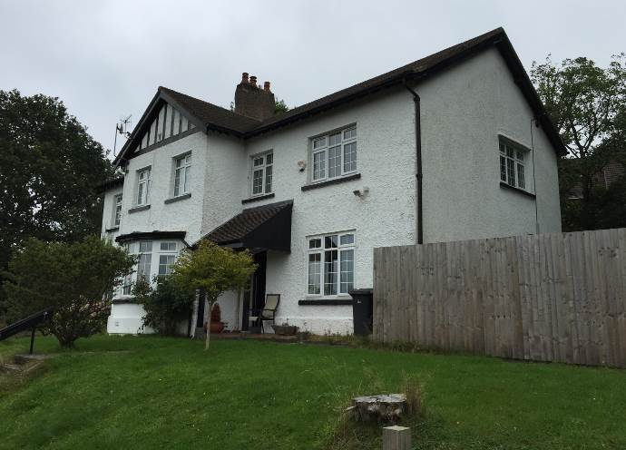

The Archdeacon will live in: MynyddIslwyn Rectory
Vicarage Lane
Pontllanfraith
Blackwood
NP12 2DP

It is a spacious five bedroomed house with a bathroom and a shower room. Downstair are separate sitting and dining rooms, a breakfast room, and a fitted kitchen with small associated utility area. The study has a separate external access and a cloakroom. Central heating is through a gas combi boiler. There is also a solid fuel stove in the sitting room and a gas fire in the study. There is a separate garage and parking for several cars. There are shops and supermarkets locally and the town of Blackwood is a short drive away.

Application Process
If you are interested in being considered for the Archdeacon of the Gwent Valleys and Diocesan Director of Mission, the application form and recruitment monitoring form can be found at https://monmouth.churchinwales.org.uk/en/about-us/jobs/

Applicants will need to submit both forms, via email, to monbishpa@churchinwales.org.uk. Please clearly head your email with “Archdeacon of the Gwent Valleys/DDM application”. You will receive an email acknowledging your application. If you have not received an acknowledgement within 24 hours, please contact us on (01633) 263510 to confirm safe receipt.

The closing date for applications is 12 noon on 14th January 2021 (Applications received after this time cannot be accepted).

The Diocese of Monmouth seeks to be an inclusive diocese and welcomes applications from people regardless of gender, sexuality, disability or ethnicity.

Applications from BAME and women are especially welcome.

Applicants from outside the UK will need to comply with the requirements of UK immigration law. Any offer will be subject to satisfying Church in Wales safeguarding policies.

For an informal discussion on this role, please call Archdeacon of Newport, Jonathan Williams on (01633) 215206.

